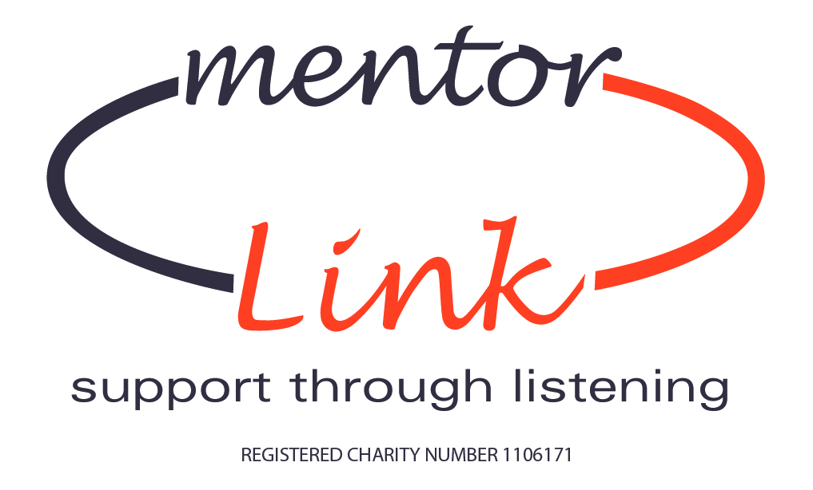

Application Form

Title ……………Surname………………………First name……………………….

Address……………………………………………………………………………….....

…………………………………………………………………………………………..

Postcode…………………….

Date of Birth………………...

Telephone Number…………………………..Mobile………………………………….

E Mail………………………………………………

Dependents……………………………….. Ages………………………………………

Do you have a full driving licence? Yes/No Do you own a vehicle Yes/No

Name of next of kin in case of emergency

Title……………Surname…………………First Name ……………………………….

Relationship………………………………..

Telephone number……………………………………

Are you currently employed? Yes/No

If Yes is this part time or full time? Part/full

Employer’s name, address and your job title.

Name……………………………………………………………………………………

Address…………………………………………………………………………………

Job Title………………………………………………………………………………

Brief outline of duties if employed ………………………………………………….

…………………………………………………………………………………………

…………………………………………………………………………………………

Please indicate how much time you have available each month

…………………………………………………………….

Do you have any previous experience of voluntary work? Yes/no

If yes- please give details

………………………………………………………………………………………………………

………………………………………………………………………………………………………

………………………………………………………………………………………………………

How did you hear about Mentor Link?

- Press advert
- Article in newspaper
- TV/radio
- Poster
- Leaflet
- Referred by a friend
- Volunteer Bureau
- From a contact using our services
- Talk/presentation

Other please give details ………………………………………

What skills do you think you can bring to the role of Head Office Volunteer?.......................................................................................................................

..........................................................................................................................................

…………………………………………………………………………………………..

What Hobbies/interests do you have?................................................................................................................................

..........................................................................................................................................

……………………………………………………………………………………………

References
Please give details of two referees who are able to support your application.

Name………………………………. Name……………………………….

Address……………………………... Address……………………………...

……………………………………… …………………………………….

Postcode…………………………….. Postcode…………………………….

Telephone number……………………Telephone number …………………

Email address …………………… Email address………………………..

Relationship………………………….. Relationship………………………..

Do you have a health problem or disability which may be relevant to your application?

Ethnic monitoring- please tick which group you identify with most (only one box)

A. White
British o

B. Mixed
White and Black Caribbean o White and Black African o White and Asian o
Any other mixed background – please write in

C. Asian.
Indian o Pakistani o Bangladeshi o
Any other Asian background – please write in

D. Black
Caribbean o African o
Any other Black background – please write in

Any other ethnic group – please write in
2. DISABILITY

Do you have enhanced CRB/DBS clearance Yes/No?

Declaration
I declare that the information given on this form is correct.

Signed…………………………… Date………………………………..

Thank you for your application form. Please note that your application is conditional upon successful completion of DBS/CRB clearance and 2 references.

Please return to:

Mrs A Maddocks MBE
Mentor Link
The Office Suite
18 Lombard Street
Stourport On Severn
Worcestershire
DY13 8DT marked “Private and Confidential”

Head office: 01299 822336
Email: Enquiries@mentorlink.org.uk

Data Protection
If you apply to become a volunteer with Mentor Link your information will be stored electronically. This information will not be shared with any other organisations other than Mentor Link and the Schools where you mentor. The Schools will process your CRB application and periodically require lists of current volunteers in the schools and CRB details for OFSTED purposes. Your contact details will only be used to update you of charity appointments, news or events.

Office Use Only

References received  CRB, date  __/__/____

Passed to Roy 

On database 

Del 

On email/newsletter list 


