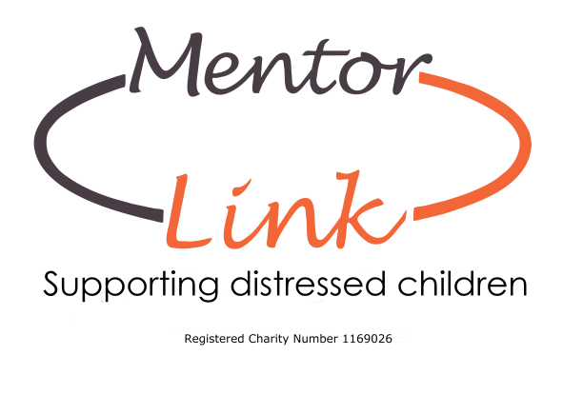
Complaints Policy

Mentor Link is committed to providing a high-quality service to all its service users. The purpose of this policy is to provide a positive response to complaints and comments and ensure that improvements are made as a result of feedback. The charity recognises that complaints can be avoided if there is good communication between all stakeholders. All stakeholders have the opportunity to:

- Make complaints about the service and the process is clear
- All complaints are taken seriously, investigated thoroughly and objectively, and dealt with professionally.
- The results are communicated to the complainant within an agreed time frame.

This policy applies to all employed staff, volunteers, parents, teachers, and young people supported by Mentor link. It covers complaints by service users, delivery partners, or members of the public in relation to services provided including:

- The standards of service that we provide.
- The behaviour of staff and volunteers working for Mentor Link.

Mentor Link recognises the right of volunteer mentors, children, young people and their parents or carers to have access to the organisation/group’s complaints procedure. A complaint is any clear expression of dissatisfaction with the organisation/group, its staff, volunteers or Trustees activities or services. We have the right to refuse to accept a complaint which is clearly vexatious and the decision on this will be taken by the CEO and Trustees.

We will ensure that all complaints are taken seriously and dealt with swiftly and in confidence and will learn from any complaints and use them to improve how we operate. In order to provide a response to complaints these will need to be in writing and contain details of contact names and address.

Complaints can be made via the following:

Andrea Maddocks MBE
CEO
Mentor Link
18 Lombard Street
Stourport on Severn
Worcestershire
DY13 8DT
Email Andrea.Maddocks@mentorlink.org.uk

Or contact our Head office on 01299 822336

Contact details for complaints will be included on our parental consent letters to parents and carers.

The CEO will be notified of any complaints received and ensure that all complaints received will be responded to initially within 7 working days accordingly and reported to the Trustees. General complaints will follow this procedure and other allegations dealt with according to our Managing Allegations policy.

Normally complaints should be made within 1 month of the event or within 3 months of the complainant becoming aware of the cause to complain.

All complaints received will be responded to appropriately, promptly, and professionally accordingly.

August 2022

