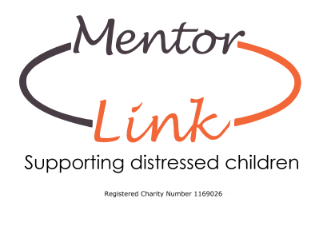

**Purpose of the Mentoring role**

To provide one to one mentoring support for children who are facing difficulties; with the aim of creating a more positive attitude towards themselves and their learning.

**Volunteer Mentor - Role description**

1. Meet your mentee on a weekly basis, term time only.
2. Provide a listening ear, support and encouragement to your mentee.
3. Ensure that you are both clear about the boundaries of the mentoring relationship and operate within those boundaries at all times.
4. Ensure that confidentiality is maintained, but that the limits of that confidentiality are understood
5. Take responsibility for developing the mentoring relationship, ensuring that mentoring goals remain the key focus of the mentoring sessions.
6. Seek out any additional information which you think your mentee would find helpful, e.g. information on courses or careers.
7. Be vigilant about potential safeguarding issues and immediately refer any disclosures/concerns to the designated person within Mentor Link and if you work in a school the designated school contact.
8. Communicate any other needs or concerns in a timely and professional manner to Mentor Link staff.
9. Let the charity staff (and if you work in a school the school) know if you cannot attend an appointment in good time or if you foresee any reason why you will be unavailable for a period of time.
10. Attend Compulsory Induction and safeguarding training within the allotted timescale and any other training/networking offered as you feel meets your needs/interests.
11. Follow the Mentor Link policies and procedures when carrying out your role at all times, please contact staff if you are unsure.
12. Ensure that there is a positive ending to the relationship, for the mentee and yourself.

**Person Specification**

No specific qualifications or work experiences are required for this role, but it is essential that you:

1. Can relate to children and young people
2. Are punctual, reliable and can commit to weekly term time sessions for a minimum 6 month period.
3. Have excellent listening and communication skills
4. Are empathetic, kind and encouraging
5. Have patience, flexibility and a willingness to persevere
6. Are non-judgemental and open minded.
7. Have a mature outlook on life and a desire to help young people.
8. Able to keep information confidential.
9. Ability to follow charity guidelines and policies and procedures.